

News from Disability Commissioner Tasmania, July-August 2026
In this edition:
- Tasmanian Leaders Program Disability Commissioner’s Scholarship
- Meet the Disability Inclusion Advisory Council
- Disability Commissioner joins Tasmanian National Preventative Mechanism
- Meet the Disability Commissioner Tasmania team in a region near you

Message from the Commissioner
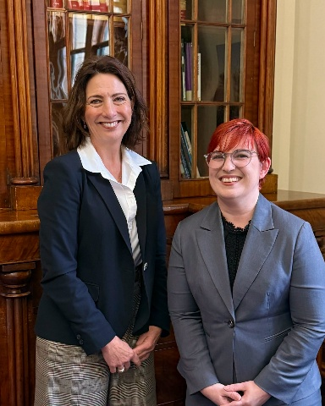
Caption: Photo of the Disability Commissioner Catherine Whitington with the Governor, Her Excellency the Honourable Caroline Wells at Government House earlier this month.
Hello everyone,
Many things have been happening, quietly, and not so quietly since our last newsletter.
During the last few months, I’ve been very focussed on how Tasmanian Statutory Officers (Commissioners, Monitors, and Ombudsmen) can work together to advance human rights and safeguarding. From this, my office has been able to become an active member of the Implementation Monitor’s Consultative group, the Ashley Youth Detention Centre’s Oversight Network, and we have also developed Memorandum’s of Understanding to work together with the Interim Commissioner for Children and Young People, the Health Complaints Commissioner, and the National Preventative Mechanism – more on this last one later in the newsletter.
In late June, I was fortunate to meet Tasmania’s 30th Governor, Her Excellency the Honourable Caroline Wells and Dr Rob Walters RFD to talk about the work of our office and priorities for the coming year. My team and I are very pleased to be welcoming Her Excellency and Dr Walters to our office later this month. Early this month, I was also pleased to meet with some of my state and territory counterparts and colleagues to learn more about programmes across the country for supporting people with disability in interacting with the justice system and to begin thinking about what might be possible to do differently in our state.
Later this year, I will be attending and speaking at conferences including the 44th Annual Advocacy Speak Out Conference, the Australian Guardianship and Administration Conference to talk about safeguarding, and the Commonwealth Parliamentary Associations’ Australia and Pacific Regional Conference. I’ll give an update about how each of these went in future newsletters.

July is Disability Pride Month, a time to celebrate our individuality and uniqueness as people with disability, as well as the solidarity that comes along with being part of a community focussed on driving change. It seemed fitting that during this time, we launched our scholarship for a Tasmanian with Disability to participate in the 2027 Tasmanian Leaders Program. My hope for this scholarship is that it helps to advance leaders with disability who would otherwise not have access to this kind of program, whether their leadership is in the disability space, or outside it altogether. Afterall, we belong in spaces where decisions are influenced and made. I encourage you to read more about it and other news from us in this newsletter.
Take care,
Catherine

New scholarship supports leaders with disability

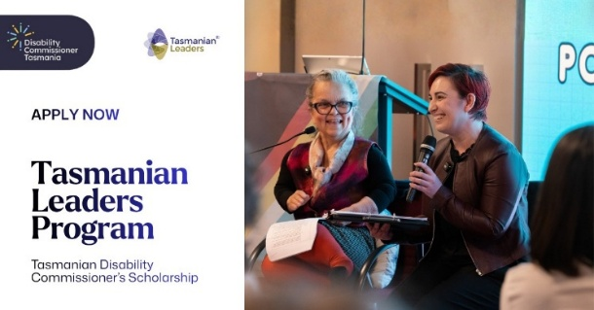
Caption: Apply now to the Tasmanian Leaders Program, Tasmanian Disability Commissioner’s Scholarship.
Disability Commissioner Tasmania is pleased to offer a scholarship for a Tasmanian with disability to participate in the Tasmanian Leaders Program.
The Tasmanian Disability Commissioner’s Scholarship will cover the full cost of the scholarship, helping current and emerging leaders with disability, access clear and inclusive pathways to leadership in their chosen field, community, or as thought leaders.
Run by Tasmanian Leaders Inc, the Tasmanian Leaders Program is an intensive part-time and year-long program for current leaders to further build their capabilities, creating a network of leaders in the state.
Read more about the scholarship and eligibility requirements on our website.

Meet the Disability Inclusion Advisory Council
Welcome and congratulations to the inaugural members of the Tasmanian Disability Inclusion Advisory Council under the new Disability Rights, Inclusion and Safeguarding Act 2024:
- Shannon Goodwin (Chair)
- Adam Quarrell
- Alex Barry
- Clare Waiss
- Dana Smith
- Dean Foreman (representing Speak Out Advocacy)
- Michael Small (representing Disability Voices Tasmania)
- Dr Monica Cuskelly
- Rubie Gallagher
- Dr Jane Dhann
- Dr Lucy Mercer-Mapstone
Members of the Council were appointed by the Minister for Disability Services in June with the Council already holding its first meeting.
The Disability Inclusion Advisory Council is an independent statutory body under the Act and will provide advice to the Disability Commissioner and Minister on systemic issues affecting people with disability in Tasmania. “”
“The Disability Inclusion Advisory Council is a significant and important step in realising the rights of people with disability in Lutruwita/Tasmania. The Council is an independent body with a majority of members being people with disability. It will be a strong and guiding voice for our community right across the state,” Commissioner Whitington said.
“The Council will set its own agenda and work towards these priorities in the timeframes they think are important. I look forward to learning more about their priorities for disability inclusion.”
Read more about Council members on our website.

Disability Commissioner joins Ashley Youth Detention Centre oversight network
Recently, Disability Commissioner Tasmania became a member of the Ashley Youth Detention Centre oversight network. Run by the Office of the Custodial Inspector, the oversight network brings together all the independent offices who can oversee or monitor the Centre. Our Office has become a member to ensure the work that we do for children and young people with disability within the Centre is consistent with and considered by our human rights and statutory peers.

Supporting the Tasmanian National Preventative Mechanism
Disability Commissioner Tasmania will support the Tasmanian National Preventive Mechanism (NPM) to visit places in the state where children and young people with disability are deprived of their liberty to make sure they are treated with dignity and respect. Places include prisons, detention centres, health, and social care facilities.
The Tasmanian NPM is an independent oversight body established to uphold the human rights of people who are deprived of their liberty. This is done through proactively visiting places to identify and make recommendations to strengthen protection of people living in restrictive environments to prevent ill-treatment before it occurs.

Events

Living My Best Life art exhibition
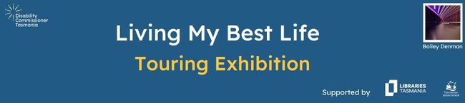
The Living My Best Life art exhibition continues to travel in the state with two new locations, Huonville and Rosny, added to the tour.
The exhibition has now opened in Queenstown, following successful visits to Devonport and Burnie libraries.
The Living My Best Life touring art exhibition is delivered in partnership with Libraries Tasmania. We encourage you to visit the exhibition at a location near you:
- Queenstown Library: closes on 5 August
- Launceston Library: 7 August to 4 September
- Huonville Library: 7 September to 5 October
- Rosny Library: 29 October to 27 November
Read more about the exhibition on our website.

Meet the Disability Commissioner Tasmania team
As the Living My Best Life art exhibition tours the state, we are hosting meet the team events to talk about the exhibition, our role, and the work we are doing. You can join in the conversation by sharing your thoughts, questions, and what is important to you in your community.
Meet the Commissioner and team at the following locations:
- Queenstown Library: Wednesday 5 August, 1:30pm to 3:00pm
- Launceston Library: Friday 4 September, 10:30am to 12:00pm
- Huonville Library: To be confirmed
- Rosny Library: To be confirmed
Read more and register your attendance for these sessions on our website.
Follow us on social media for the announcement of further dates.

Disability Expo ‘Gearing Up for Choice & Control,’ Speak Out Advocacy
Disability Commissioner Tasmania will attend Speak Out’s Disability Expos in Hobart, Launceston, and Devonport. These expos help to connect people with disability, their families, and supporters to specialist businesses and NDIS service providers.
- Hobart: 26 August 2026, MAC Wharf 02
- Launceston: 16 September 2026, Launceston Conference Centre
- Devonport: 29 September 2026, paranaple arts centre
More information can be found on the expo website: https://disabilityexpotas.org/

Other News

New national emergency warning system coming soon
AusAlert, a new national emergency warning system that sends messages to compatible mobile devices about local and national emergencies, will be released on 1 October.
AusAlert is another way to help people stay safe in an emergency. Anyone with a compatible mobile device near the area affected by an emergency, will receive an alert. The alert may include contact information about the type of emergency, where it is, how serious it is, the actions you need to take, and where more information can be found. You do not need to register or download an app to receive an emergency message via AusAlert.
Testing is currently being done in communities to ensure the system works before its release. This will include a national test of a critical alert being sent to all mobile devices in Australia on 27 July (2:00pm in Tasmania). You do not need to do anything if you do or do not receive this test alert. More information on AusAlert, accessibility, and testing, can be found on the AusAlert website: https://www.ausalert.gov.au/

Awards and honours to recognise and celebrate excellence
If you know someone who has made a significant contribution in their chosen field and community, consider nominating them for the following awards and honours.
- 2026 Disability Confidence Awards – For individuals and organisations advancing disability inclusion. Nominations can be made via the Australian Disability Network website. Nominations close 14 August.
- 2026 Human Rights Award: Recognising individuals and organisations that champion human rights in the categories of law, media and creative industries, community, young people, and the Human Rights Medal. Nominations can be made on the Australian Human Rights Commission website. Nominations close 3 August.
- 2027 Tasmanian Australia of the Year Awards: Recognising the achievements and contributions of Tasmanians in their community across the categories of Australian, Senior Australian, Young Australian, and Local Hero. Nominations can be made on the Australian of the Year Awards website. Nominations close 31 July.
- 2027 Order of Australia Honours – Recognising outstanding service or exceptional achievement. Nominations can be made at any time via the Office of the Official Secretary to the Governor-General’s website.

New Resources

Australian Public Service (APS) Inclusive Onboarding Toolkit: Disability and Neurodivergence
The Australian Public Service Commission (APSC) has released a new best practice Inclusive Onboarding Toolkit to welcome and support new employees with disability and neurodivergence. More information is available from the APSC’s website.

Research

Powering participation: Insights on menstruation support needed for people with disability in sport
Share the Dignity and Victoria University recently published research insights on menstruation support needed for people with disability in sport. The research identified that 68 per cent of women and girls with disability miss sport due to menstruation. The research revealed that participation could be improved with accessible period products and sport facilities, normalised conversations around periods, information, support, and education. The report can be read on Victoria University’s website.

Office update

Welcome Jane Green
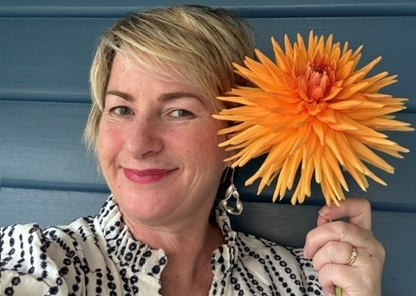
Caption: Photo of our Assessment Officer, Jane Green.
Jane Green is our Assessment Officer until December 2026.
Jane has university degrees in Arts and Law and has lived experience of disability. She has worked as both a private and a community lawyer in personal liability, complaints, investigations, and policy. She is passionate about trauma-informed care, accessibility, inclusion, and human rights. Outside of work, Jane relishes time with her family, reading, painting, and gardening - growing dahlias is her speciality.

Welcome Ruby Shaw

Ruby has temporarily joined the team until the end of September, providing backfill administrative support while our Project Support Officer, Trish Mullins, is on long service leave. Ruby usually works in the Office of the Chief Risk Officer within the Department of Health.

Strategic plan and values development update
Recently, our office worked alongside facilitators Dr Josie McLean and Lucy Byrne to begin work on our first strategic plan and shared office values.
We enjoyed working with both facilitators to become clear about the way we will operationalise the Act in the future and the values that drive the work we do. The Commissioner and team are now working together to take the content from these workshops and shape them into our office values and a multi-year strategic plan that will be available on our website in accessible formats.

We welcome feedback on our newsletter
Thank you for reading our newsletter. If you have any suggestions or would like to provide us with feedback, please contact us.

How to contact us
- Phone: 1800 179 249 (free call) or 03 6270 5500
- Email us at: contact@disabilitycommissioner.tas.gov.au
- Visit our website: www.disabilitycommissioner.tas.gov.au
- Write us a letter: Disability Commissioner Tasmania, GPO Box 123, Hobart 7001
- Visit us: Level 5, 188 Collins Street, Hobart, 7000. Our office hours are 9:00am-5:00pm, Monday to Friday. Find more information on how to get to our office on our website.

Make a Report
If you are concerned about the safety or wellbeing of someone with disability, make a report to us.

Connect with us on social media
Follow Disability Commissioner Tasmania on Facebook.
Follow Disability Commissioner Tasmania on LinkedIn.
Follow Disability Commissioner Tasmania on YouTube.

About this newsletter
Thank you for reading our newsletter. You can read this issue and others as they are distributed on our website.

