
Progress Report
12 May to 12 December 2025
Your Voice. Your Rights. Our Purpose.

Progress Report:
12 May to 12 December 2025
Forward from the Commissioner 3
About Disability Commissioner Tasmania 4
Our Structure and Team 5
Image of Disability Commissioner Tasmania’s organisational structure 6
Out and About in the Community 6
Events 9
Office launch 9
Living My Best Life Art Exhibition 10
Policy Work and Regulatory Development 12
Policy Work 12
Regulatory Development 13
Reports, Enquiries and Contacts 14
Reports 14
Enquiries 16
Disability Inclusion Action Plans 16
Disability Inclusion Advisory Council 16

Forward from the Commissioner

Friday 12 December 2025 is a date of significance for Disability Commissioner Tasmania (DCT). Not only does it mark seven months since my commencement as Tasmania’s inaugural Disability Commissioner, but it also marks approximately five months since the proclamation of the Disability Rights, Inclusion and Safeguarding Act 2024 (the Act) and our commencement as a safeguarding authority.
As you read through or listen to this progress update, I hope you will see and hear the unwavering pride and commitment I share with my team to the advancement of human rights and inclusion of Tasmanians with disability.
Some of our key achievements to note include:
- The launch of our dedicated, accessible office space;
- Developing and recruiting an office staffing structure;
- Developing and implementing our report management, assessment and investigation frameworks;
- Developing the regulatory framework for Disability Inclusion Action Plans;
- Developing a recruitment strategy and materials for the Disability Inclusion Advisory Council;
- Receiving and responding to over 100 reports and enquiries;
- Contributing to the review of the Federal Disability Discrimination Act 1992; and
- The ‘Living my best life’ art exhibition in anticipation of consultation for the Tasmanian Disability Inclusion Plan.
In early 2026, I look forward to beginning recruitment for the Council, launching our regulatory framework for Disability Inclusion Action Plans and continuing to work alongside and within Tasmania’s vibrant disability community.
Catherine Whitington
Disability Commissioner

About Disability Commissioner Tasmania
The Tasmanian Disability Commissioner is a new independent authority established under the Disability Rights, Inclusion and Safeguarding Act 2024 (The Act). Disability Commissioner Tasmania refers to the Commissioner’s office and the team working to assist the Commissioner in carrying out their roles and functions under the Act. Our role is to prevent harm, promote inclusion, and ensure that people with disability are treated with dignity and respect.
The Act gives us a broad range of powers, with a focus on:
- Development of a Tasmanian Disability Inclusion Plan to establish whole-of-government policies to advance and safeguard inclusion of people with a disability in Tasmania;
- Regulating Disability Inclusion Action Plans that help government agencies improve access, uphold disability rights, and remove barriers;
- Receive and investigate reports of violence, abuse, neglect, coercion, and exploitation that involve people with disability; and
- Establish and maintain a Disability Inclusion Advisory Council to advise on policies and practices, promote full participation of people with disability in community life, monitor and report on the implementation of disability inclusion plans.

Our Structure and Team
An image of our organisational structure is shown below. This image shows the following team report directly to the Disability Commissioner:
- The Deputy Disability Commissioner, who we expect to commence full time employment in 2026;
- A Media and Communications Consultant who is employed full time; and
- A Project Support Officer who is employed part time, working four days per week.
The image also shows the following team members reporting to the Deputy Disability Commissioner:
- An Assessment Officer who is employed full time;
- A Policy and Program Officer who is employed part time, working four days per week.
- A Project Officer who is employed part time, working 20 hours per week across 3 days.
There is one executive in Disability Commissioner Tasmania and all other roles are classified in line with the State Service Act 2000 between General Stream Band 4 and General Stream Band 8.

Image of Disability Commissioner Tasmania’s organisational structure

Out and About in the Community
Between May and December, the Commissioner and her team participated in a range of community events and conferences, contributing as speakers on some occasions. The Commissioner has also met with individual members of the Disability Community and organisational stakeholders. Some of these include:
- The final meeting of the Premier’s Disability Advisory Council (PDAC) and celebration to conclude both PDAC and the Minister’s Disability Consultative Group (MDCG);
- The Hobart Aged & Disability Expo;
- The Working it Out ‘Including Us’ launch;
- Students and Faculty at the University of Tasmania Law School;
- SpeakOut Advocacy’s Gearing Up Disability Expos and conference;
- Remembering Willow Court event;
- The Public Trustee stakeholder reference group;
- The Launceston Community Legal Centre;
- The State Service Defined Entities Working Group;
- The Disability Reform Steering Committee;
- The Tasmanian Institute of Sport’s Para Unit Launch;
- National Disability Services Executive Leader’s conference;
- The Tasmanian Disability Awards;
- National Disability Services Webinar;
- Women’s Legal Service: Small Steps, Safe Workplaces Conference;
- The Clarence Access and Inclusion Network;
- Young Leader’s of Tasmania official graduation;
- Tasmanian Legal Aid International Day of People with Disability celebrations;
- The Crip Culture Podcast Launch;
- The commemoration of the 25th anniversary of the closure of Willow Court;
- Meeting with various departmental secretaries across the state service;
- Meeting with the NDIS Commissioner and Associate Commissioner;
- The Tasmanian Statutory Authorities Working Group;
- Equality Building;
- Our Watch;
- The Victorian Disability Worker Commissioner;
- Public Trustee Board Meeting;
- The Tasmanian Law Society;
- TasCOSS;
- Disability Voices Tasmania;
- The Brian Injury Assocation of Tasmania;
- Bus Stop Films;
- The National Disability Insurance Agency; and
- The Focus on Ability Film Festival.

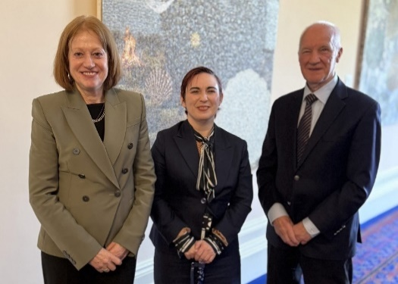
Figure 1: the Commissioner meeting with Her Excellency the Honourable Barbara Baker AC, Governor of Tasmania, and Emeritus Professor Don Chalmers AO.
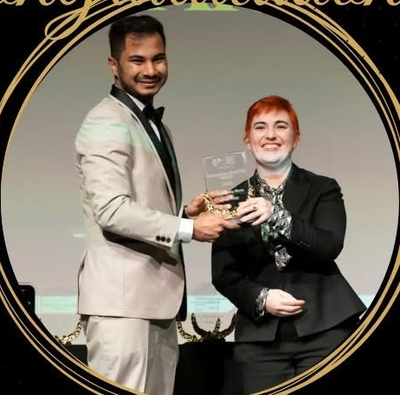
Figure 2: The Disability Commissioner handing the Community Hero of the Year Award to Chathura Dissanayake at the 2025 Tasmanian Disability Awards.
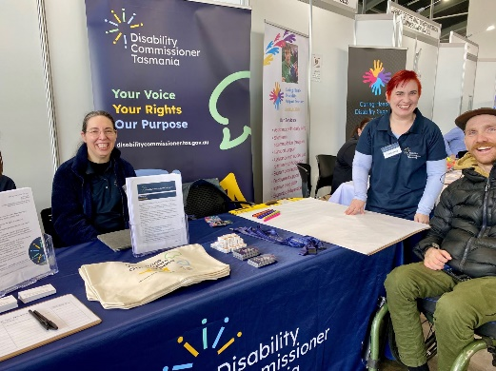
Figure 3: Felicity (Policy and Program Officer), the Commissioner, and Gordy from SES at the Speak Out Expo in Hobart.
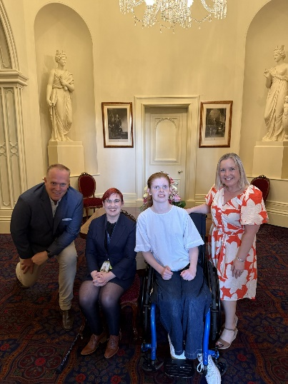
Figure 4: Young Leaders of Tasmania Graduation in November 2025. Photo: Lynne Moran Photography.
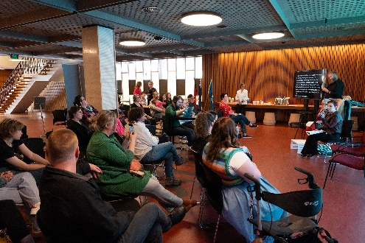
Figure 5: Launch of the Crip Culture Podcast. Photo: Paul Redding.

Events
In addition to the events included above, the Commissioner also hosted two events.

Office launch
On 25 November, Disability Commissioner Tasmania’s Hobart office was officially opened by Her Excellency, the Honourable Barbara Baker AC, Governor of Tasmania.
The office launch was attended by many members of the Disability Community, Tasmanian statutory officers and the Department of Premier and Cabinet.
Alongside the Governor, the Commissioner and Minister for Disability Services, the Honourable Jo Palmer MP, spoke about the development of the Tasmanian Disability Commissioner and the accessible features of the Hobart office. These include but are not limited to:
- Height adjustable work stations, counters, meeting room tables;
- Height adjustable kitchen cabinetry and benches;
- Lowered reception desk;
- Varying height chairs;
- Braille and raised lettering signage;
- Adjustable brightness and warmth of lights;
- Motorised blinds;
- A wellness room with sensory aids;
- Accoustic baffling;
- Way finding used in carpets;
- Accessible light switches and powerpoints;
- Correct ciculation space for mobility aids and devices;
- Charging ability for mobility aids and devices;
- A specialised colour pallete within the office; and
- Automatic doors.
In 2026, the Commissioner will continue exploring options for satellite bases in the north of the state.
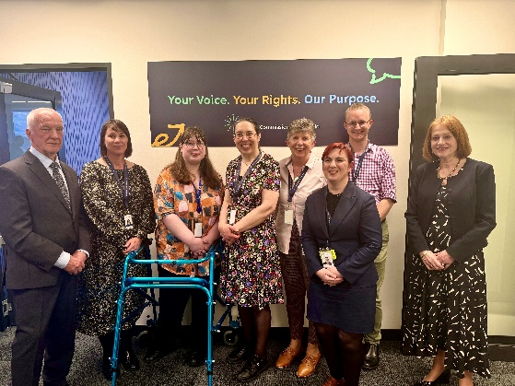
Figure 6: The Disability Commissioner Tasmania team with Professor Chalmers AO, and Her Excellency, the Honourable Barbara Baker AC, Governor of Tasmania.

Living My Best Life Art Exhibition
On Wednesday 10 December 2025, in celebration of International Day of People with Disability and Human Rights Day, the Commissioner hosted a 2-day art exhibition at the Moonah Arts Centre. The exhibition is also supported by an online gallery which will remain hosted on the Commissioner’s website.
The exhibition was themed ‘Living My Best Life.’ 19 Artists with disability of diverse ages, locations in Tasmania and stages of their artistic careers, exhibited work directly addressing the question ‘what is living your best life in Tasmania’. Each piece was an individually unique work presented in different mediums, from painting through to poetry, textiles, ceramics, and song. Together, they created an authentic conversation about inclusion and belonging, timed specifically to occur as consultation opened on the Tasmanian Inclusion Plan.
The physical gallery attracted just under 100 attendees, with more joining via livestream. The online gallery has continued to draw interest, receiving 318 page views in the week since its launch. Disability Commissioner Tasmania received overwhelmingly positive feedback about the exhibition, both from the Disability Community and the broader Tasmanian community. A highlight for the Commissioner and team, was feedback from community members who had not engaged previously with disability yet explored the themes of inclusion and belonging with thoughtfulness and care.
In 2026, the Commissioner has partnered with Libraries Tasmania to tour the exhibition around the state. The Commissioner will accompany the artwork, creating organic opportunities for community engagement outside of the Hobart region.
View the Online Gallery – ‘Living My Best Life’ Art Exhibition.
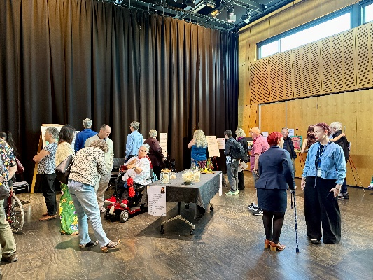
Figure 7: Living My Best Life Art Exhibition official opening.
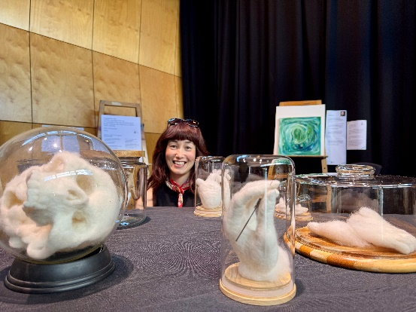
Figure 8: Artist Lisa Rime with her felted sculptural work, ‘Pieces of Myself’.

Policy Work and Regulatory Development

Policy Work

Submission to the Review of the Disability Discrimination Act 1992
The Commissioner made a submission to the review of the Commonwealth Disability Discrimination Act. In this submission, the Commissioner supported the notion of a positive duty to prevent discrimination, modernising the language of the legislation to ensure inclusion and a strengths-based approach, and modernising the legislation to keep pace with broader developments in anti-discrimination law and practice.
Read the Commissioner’s submission to the review of the Disability Discrimination Act.

Participation in the National Consultation on Disability-Specific Community Visitor Schemes
The Commissioner participated in the National Consultation on Disability Specific Community Visitor Schemes. In doing this, the Commissioner drew on her experience with Community Visitor Schemes in other parts of Australia and put forward new work completed by Equality Building and SpeakOut in relation to the development of a Community Visitors Scheme in Tasmania.

SafetyTAPS
The Interim Commissioner, Mary Mallet, in partnership with the Department of Premier and Cabinet, commissioned Equality Building to undertake work to inform the development of the Commissioner’s office and work. The SafetyTAPS project resulted, in part, in the development of a disability specific taxonomy of harm and assessment tool. Harnessing the narratives from the Australian Disability Royal Commission, these tools allow for an evidenced based approach to classifying, predicting, and responding to harm.
Further safetyTAPS project work may occur in the future.

Submissions currently in progress
The Commissioner is currently working on additional policy submissions to both the NDIS Reform Disability Safeguards Consultation and the Commonwealth Disability Advocacy Program. These submissions will be completed in mid-late December and January 2026, respectively.

Internal frameworks and policy development
In 2025, the Commissioner has developed a framework and internal procedures for the assessment and investigation of reports made under the Act. Other internal policies and frameworks developed include:
- Delegations for decision making under the Act;
- Information sharing and privacy;
- Consent and authority;
- Vicarious trauma management;
- Guidelines for welfare checks;
- Preliminary inquiry into reports; and
- Processes and guidelines for own motion investigation.

Regulatory Development
The Commissioner has developed a framework based on principles of responsive regulation for the regulation of Disability Inclusion Action Plans under the Act. This framework includes all relevant internal documentation including compliance notices and templates for voluntary and enforceable undertakings.
To finalise this regulatory framework, the Commissioner is currently working on a charter of rights, a model Disability Inclusion Action Plan, and education packages for both defined entities and the broader community. These materials will be available in the first quarter of 2026. The Commissioner has also met with the NDIS Quality and Safeguards Commission who are developing their own charter of rights to ensure that Tasmania’s charter is consistent with other international and domestic rights-based instruments.

Reports, Enquiries and Contacts
Between July and December 2025, Disability Commissioner Tasmania received 120 reports and enquiries made under the Act. Prior to July, contacts from the public raising concerns about a person with disability were not classified as reports or enquiries. For each of these matters, advice, information and referral options were given. The cumulative total of all contacts raising concerns about a person with disability between 12 May 2025 and 12 December 2025 is 327. We have also received an additional number of contacts that do not raise concerns about a person with disability.

Reports
A report is made under section 36 of the Act. The Commissioner accepts reports in many formats, and these do not have to be written. While the Act allows the Commissioner to accept reports about the abuse, coercion, neglect or exploitation of a person with disability, a matter may still be considered a report even if it falls outside of this scope. Importantly, a matter is deemed a report when it has all information required for the Commissioner to form an assessment under the Act or has sufficient information to set out a matter of abuse, coercion, neglect or exploitation. If a matter does not have sufficient information, it is considered an enquiry while the Commissioner’s team gather sufficient information from the reporter and/or person with disability to assess the matter’s direction under the Act.
A matter can begin as an enquiry and progress to a report. Some matters are classified a report on receipt.
51 reports have been accepted as reports on receipt between 1 July 2025 and 12 December 2025 that fall within the Disability Commissioner’s jurisdiction under the Act. Of these, 39 were made directly by the person with disability. A further 10 were made by a concerned friend, neighbour or family member while 2 were made by a paid member of the person’s care team.

Report Issues
The following percentages show the common issues raised in received and accepted reports from 1 July and 12 December. Please be aware a report may raise more than one issue and therefore these percentages will not total 100.
Abuse (including sexual abuse): 30.2 percent
Coercion: 11.7 percent
Neglect: 29.4 percent
Exploitation: 13.7 percent
Other issues raised in reports which fall outside of the Commissioner’s jurisdiction to consider as individual reports include:
Housing: 3.9 percent
Child Safety: 1.9 percent
Education: 1.9 percent
NDIS Funding or NDIS related service concerns: 15.6 percent
Guardianship: 3.9 percent
Health Services: 9.8 percent
As of 12 December 2025, 27 reports remain open, either for assessment or the completion of preliminary inquiry under section 36(3) of the Act. Where a report within the Commissioner’s jurisdiction has been finalised or closed, this is because the matter has been referred to an existing authority or complaints body. Examples of this include Tasmania Police, the Tasmanian Health Complaints Commissioner, Ombudsman Tasmania or the federal NDIS Quality and Safeguards Commission.

Enquiries
An enquiry is a contact made with Disability Commissioner Tasmania that may or may not go on to be a report. An enquiry may be about a subject outside of the Commissioner’s jurisdiction or may not contain sufficient information to yet be considered a report. Sometimes an enquiry may also be a request for advice about the best body or agency for a person to approach about a concern.
Between the reporting period, Disability Commissioner Tasmania received 69 enquiries. The issues of these enquiries ranged in nature from concerns about engaging with telephone communication providers, through to the accessibility of polling booths and school bullying issues for young people with disability.
As of 12 December 2025, 7 enquiries remain open while the Disability Commissioner Tasmania team gather further information to assist. Where an enquiry has been closed it is either because sufficient information has been gathered to now consider the matter a report, or the enquirer has been provided with advice and information to address their concerns.

Disability Inclusion Action Plans
During the past 7 months, the Commissioner has met with a range of defined entities and other organisations to discuss Disability Inclusion Action Plans. Many defined entities already have these plans in place or have taken proactive steps toward consultation and development. In each of these meetings, the Commissioner has outlined the need for these plans to move beyond service delivery into cultural tools, including reflecting the inward state of organisations such as the recruitment, safety, and retention of team members with disability.

Disability Inclusion Advisory Council
To support the recruitment and commencement of the Disability Inclusion Advisory Council, Disability Commissioner Tasmania has:
- Completed terms of reference and a Code of Conduct for council members;
- Undertaken a sizing process and determined levels of payment for council members;
- Developed a range of recruitment materials in varying accessible formats;
- Planned a range of engagement activities across the recruitment process;
- Developed a process for shortlisting and then recommending potential council members, including the Chair, to the Minister for Disability Services.
Although the Commissioner had hoped to commence recruiting for the Council in November 2025, recruitment will now commence in January 2026 and remain open until the end of March 2026.
Disability Voices Tasmania will also work alongside the Commissioner to support the Disability Community, participating in the recruitment process and building governance and advisory skills.

