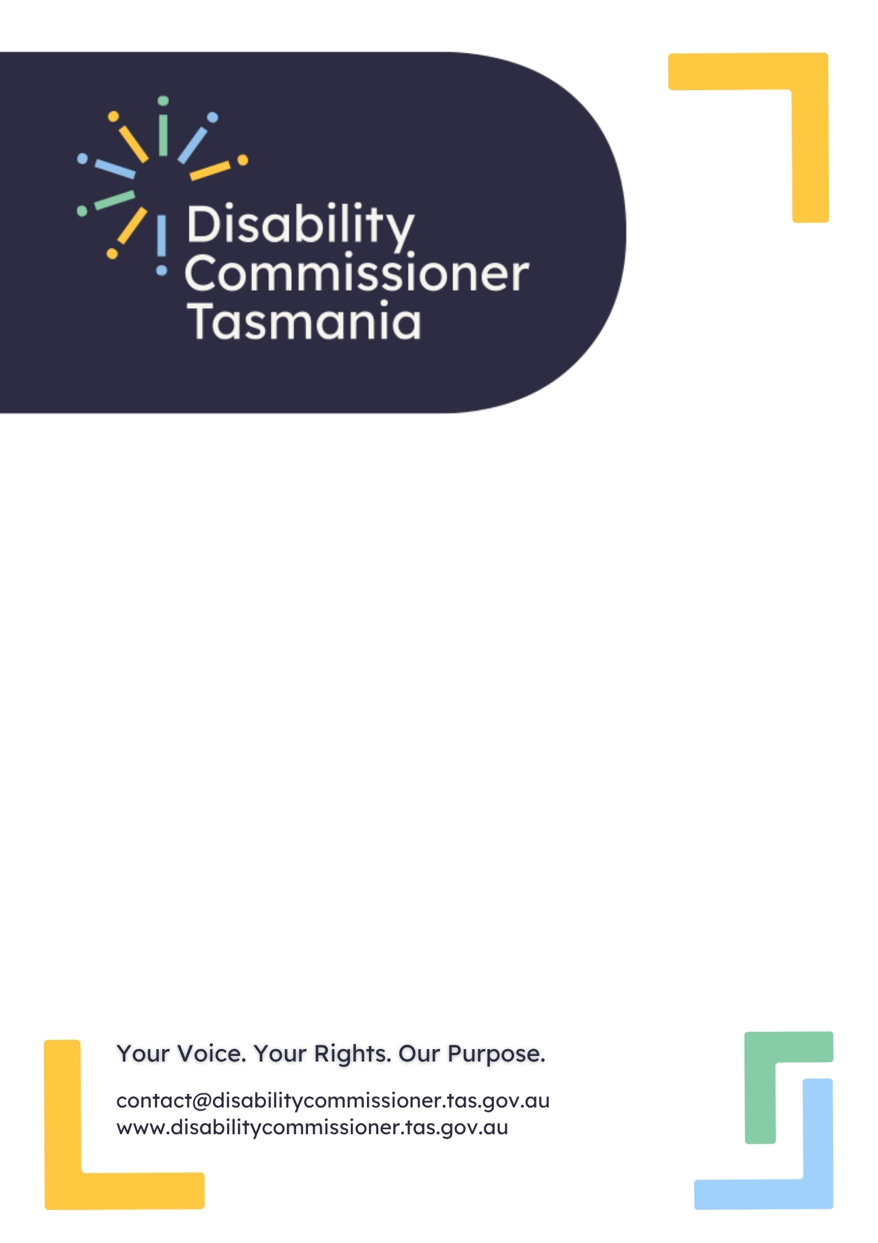

Submission to the
Disability Safeguards Consultation
22 December 2025

Acknowledgements
Disability Commissioner Tasmania (DCT) respects the Palawa and Pakana peoples as the Traditional Owners and continuing custodians of Lutruwita (Tasmania), where this submission was written. We honour their enduring connection to land, waters and skies, and pay our respects to Elders past and present.
We acknowledge and thank Tasmanians with disability, along with their families and supporters whose lived experience continues to shape our work. As an organisation, we are committed to inclusive and accessible engagement. We stand in solidarity with those across Australia who have shared their personal stories and/or worked to advance human rights.

Table of contents
Acknowledgements 2
About Disability Commissioner Tasmania 4
About this submission 5
Our submission 6
Part 1 – What do we mean by safeguards and quality? 6
Question 1: When you hear the words “safeguards” and “quality” in this context, what does it mean to you? 6
Question 4: Do you have anything to add? 6
Part 2 – What are the components of effective safeguarding? 7
Question 7: What makes it difficult for people to access, understand and use information to make decisions? 7
Question 12: How can services get better at putting the person first? 7
Question 15: Are there other forms of accountability you think would increase quality and safety? 8
Question 16: What could be changed to keep services accountable? 8
Question 19: Are there things that stop services working well together in your experience? 8
Acronyms 9

About Disability Commissioner Tasmania
The Tasmanian Disability Commissioner is an independent authority established on 1 July 2025 under the Disability Rights, Inclusion and Safeguarding Act 2024 (the Act). Disability Commissioner Tasmania (DCT) refers to the office and staff supporting the Commissioner to deliver their functions under the Act.
The Tasmanian Disability Commissioner is a regulator, working to protect and promote the rights of people with disability across Tasmania/Lutruwita to create safer, inclusive and accessible communities.
While the Act gives the Commissioner a broad range of functions and powers, DCT’s work focuses on three key areas:
- Driving systemic change through the regulation of Disability Inclusion Action Plans created by government agencies (referred to in the Act as defined entities);
- Receiving and investigating reports of violence, abuse, neglect, coercion, and exploitation of people with disability; and
- Monitoring and investigating systemic issues of concern to Tasmanians with Disability.

About this submission
This submission is made on behalf of the Tasmanian Disability Commissioner. The Commissioner welcomes the opportunity to contribute to the development of the Disability Support Quality and Safeguarding Framework and the Disability Support Ecosystem Safeguarding Strategy. These initiatives are a critical part of creating a national approach to preventing harm while supporting autonomy and ensuring dignity.
Reform must be practical, enforceable, and easily engaged with by the community whose rights it seeks to advance and protect.
Tasmania’s context shapes our perspective on safeguarding. Our state is the second-most digitally disadvantaged in Australia, with around 25% of Tasmanians facing barriers to digital access and approximately 54,000 people highly digitally excluded. In addition, 18.7% of households lacked internet access, and 30.5% of Tasmanians have disability compared to 21.4% nationally. These realities mean that reforms cannot assume universal digital access or high literacy. Safeguard information must be available in multiple formats—printed copies, Easy Read, Auslan, spoken explanations, and phone numbers answered by real people. It should also include adjustments such as interpreters and be provided through community access points like libraries and service hubs. Without these measures, those most at risk may be excluded from understanding and using protections.
The views in this submission draw on the principles of the Convention on the Rights of Persons with Disabilities (CRPD), findings of the Royal Commission into Violence, Abuse, Neglect and Exploitation of People with Disability (Disability Royal Commission), and early themes emerging from the small volume reports and enquiries made under the Act to date. Rather than provide prescriptive solutions, we recognise cultural change and legal reform must progress together.
We have not responded to each question in the Consultation Paper individually. Instead, we have consolidated our input to avoid repetition and focus on systemic issues where we can contribute meaningfully.

Our submission

Part 1 – What do we mean by safeguards and quality?

Question 1: When you hear the words “safeguards” and “quality” in this context, what does it mean to you?
Safeguards are protections that go beyond ensuring basic physical and psychological safety, to also uphold the human rights of people with disability consistent with the principles of the CRPD. Effective safeguards work alongside other models and frameworks of choice and control, supported decision-making, and trusted relationships. Where needs compete, safeguards should always be interpreted and implemented in the least restrictive manner.
Quality means moving beyond compliance to being co-designed person-centred, culturally safe, rich and rights-based. It is about consistency, respect, and accountability—ensuring demonstrated reliability, transparency and continuous improvement beyond minimum standards. Quality should reflect CRPD principles of inclusion, participation, and equality, and be measured by outcomes that matter to individual people and collective groups.
Current definitions of both safeguards and quality are positive and also incomplete. They do not fully address the tension that arises when autonomy is affirmed without supports, exposing people to foreseeable harm. Emphasising “choice and control” without supported decision-making, capacity checks, and communication access can lead to overcorrection. Research shows many people complain through silence or withdrawal rather than formal channels. Systems must notice and respond to these signals.

Question 4: Do you have anything to add?
Safeguarding cannot be effective without embedding supported decision-making as a core principle. This means proportionate capacity checks for high-stakes actions, practical tools to help people enact decisions, and continuity of safeguards to prevent harm when roles change. Prevention must be real: early risk identification and contingency planning for provider exits or service transitions, as an example.

Part 2 – What are the components of effective safeguarding?

Question 7: What makes it difficult for people to access, understand and use information to make decisions?
The Disability Royal Commission recommended a ‘no wrong door’ approach (Recommendation 10.20), meaning any agency that receives a concern should take responsibility for connecting the person to the right body through warm handovers. This matters because people often do not know which authority can help—and many never disclose at all. When someone does reach out, they need confidence that they will not be turned away or left without action because they chose the wrong entry point. Knowing that any door will lead to help builds trust and psychological safety, which in turn empowers people to speak up and exercise their rights. Clear, time-bound feedback loops reinforce this trust by showing that action is being taken and explaining what will happen next.
As outlined in About this submission, Tasmanians face unique barriers to accessing safeguarding information. High levels of digital disadvantage mean that when information is provided only online or in complex written formats, many people cannot find or use it. This makes it harder to understand safeguards and make informed decisions. Limiting information to digital channels does not reflect Tasmania’s context and risks excluding those most at risk. Multi-format delivery and physical access points are essential to ensure people can access, understand, and act on safeguards.

Question 12: How can services get better at putting the person first?
Supported decision-making should be the default across systems, with practical tools, communication adjustments, and trusted supporters to help people understand options and enact decisions. Alongside this, supported decision making must be adequately resourced. Implementing supported decision-making frameworks and processes without adequate resource models (for example in legal and tribunal settings) creates further risk and, potentially harm. For high-stakes actions proportionate capacity checks should be used alongside processes that ensure risks and alternatives have been explained in accessible ways. These measures align with the Disability Royal Commission’s Recommendation 6.13, which calls for information, education and training to make informed choice real.
Plans and risk tools should be co-designed with people with lived experience and include continuity guardrails for provider exits or service transitions—backup providers, interim plans, and agreed escalation triggers—so supports do not collapse during change. Role clarity across jurisdictions is critical: where responsibility sits with Commonwealth review mechanisms (e.g., the Administrative Review Tribunal for NDIA decisions), state decision-makers should provide accessible information, warm handovers, and continuity supports rather than defaulting to substitute decision-making.

Question 15: Are there other forms of accountability you think would increase quality and safety?
Staff capability underpins quality and safety. Training should include communication access, trauma-informed practice, supported decision-making, and recognising non-verbal feedback. Complaints recognition must be broad: spoken, video, and assisted submissions should be accepted everywhere, not just online forms. Embedding warm handovers and feedback loops across agencies ensures concerns are addressed rather than redirected, and helps build a culture of early response and continuous improvement.
Question 16: What could be changed to keep services accountable?
Accountability needs to move beyond reactive compliance toward proactive, prevention-focused systems. People should know what to expect after making a report. Transparent communication standards can set indicative timeframes for each stage and require regular updates on progress—even when investigations take time—so people have confidence in the process without imposing rigid deadlines. Quality should be measured by what matters to the person (safety, dignity, predictability), not only by compliance metrics. Embedding these accountability measures within the Disability Support Quality and Safeguarding Framework and the Disability Support Ecosystem Safeguarding Strategy will help ensure that quality is not just compliance-driven but focused on outcomes that matter to people with disability.

Question 19: Are there things that stop services working well together in your experience?
Collaboration frequently breaks down because of jurisdictional boundaries, unclear lead responsibility, and siloed information systems. When these gaps persist, people can be placed in institutions such as hospital, or prisons, not because it is clinically appropriate, but because it appears to be the only way to keep someone safe. Individuals may remain in hospital, detention, or emergency settings in the absence of community-based safeguards and disability-informed crisis responses, distancing people from family and community and increasing trauma.
Effective safeguarding requires systems to work together in a coordinated way. To prevent these outcomes and inform the development of the Disability Support Ecosystem Safeguarding Strategy, options may include:
- Activating contingency planning for provider exits and service transitions, including backup providers, interim plans, and agreed escalation pathways.
- Funding local coordination pilots, such as disability-informed case conferencing at high-risk interfaces.
- Implementing proactive risk assessments to strengthen early intervention.
- Prioritising cross-jurisdictional collaboration and integrated information-sharing through the Disability Support Ecosystem Safeguarding Strategy.

Acronyms
DCT Disability Commissioner Tasmania
CRPD Convention on the Rights of Persons with Disabilities
The Act Disability Rights, Inclusion and Safeguarding Act 2024 (Tas)

Disability Rights, Inclusion and Safeguarding Act 2024 (Tas).
N1
N1
N1
Tasmanian Council of Social Service, Digital inclusion in Tasmania (2025) TasCOSS.
Australian Bureau of Statistics, Household use of information technology (2016) ABS.
Australian Bureau of Statistics, Survey of Disability, Ageing and Carers (Table 4.3, 2022). ABS.
Convention on the Rights of Persons with Disabilities, opened for signature 13 December 2006, 2515 UNTS 3 (entered into force 3 May 2008).
Royal Commission into Violence, Abuse, Neglect and Exploitation of People with Disability, Final report recommendations (2003).
N1
N8
N8
Paul Tomaszewski, Karen R Fisher, Sally Robinson and Heikki Ikäheimo, ‘Rethinking How People with Cognitive Disability Complain’ (2025) Disability & Society.
N9
N9

